AGREEMENT BETWEEN PUBLISHER, EDITOR AND CONTRIBUTOR
FOR THE PUBLICATION OF A CONTRIBUTION IN THE JOURNAL
Annales Universitatis Apulensis. Series Historica

From: Daniel Dumitran, Chief Editor,  Annales Universitatis Apulensis. Series Historica | To:
Contribution:

SC MEGA PRINT SRL, Editura Mega of Cluj-Napoca, 3 Parcul Feroviarilor St., J12/2888/2004, CUI: RO15624991 (hereafter Publisher) has agreed to publish your contribution in the journal Annales Universitatis Apulensis. Series Historica (hereafter Journal). The agreement is contingent upon the fulfilment of a number of requirements listed below.

- The contributor warrants that the contribution is original, that no part of it has been previously published, not even in another language, and that no other agreement to publish it or part of it is outstanding, that it does not infringe any copyright or other proprietary right.
- By submitting the contribution, the contributor agrees to transfer the rights to publish and sell the contribution in any binding or medium to Publisher. These rights are governed by a contract between the editor of the Journal and the Publisher.
- The contributor agrees to make a reasonable effort to conform to the Journal’s submission guidelines.
- The Publisher grants to you the following nonexclusive rights, subject to your giving proper credit to the original publication of the contribution in the Journal, including reproducing the exact copyright notice as it appears in the Journal:
- To use the contribution for teaching purposes, including making multiple copies, either as individual copies or as a part of a printed course pack.
- To post a copy of the contribution on your personal or institutional web server, provided that the server is noncommercial and there are no charges for access.
- To deposit a copy of the contribution in a noncommercial data repository maintained by an institution of which you are a member.


Please complete, sign, and date this agreement, and return it to the editor by mail, fax, or e-mail. An electronic signature may be used.

AUTHOR SIGNATURE:  _____________________________________ | FOR THE PUBLISHER:
Name: _______________________________  _____________________________________ | Cristian Sincovici, Director
Date: _____________ | FOR THE EDITOR
Address: ______________________________  ______________________________________ | 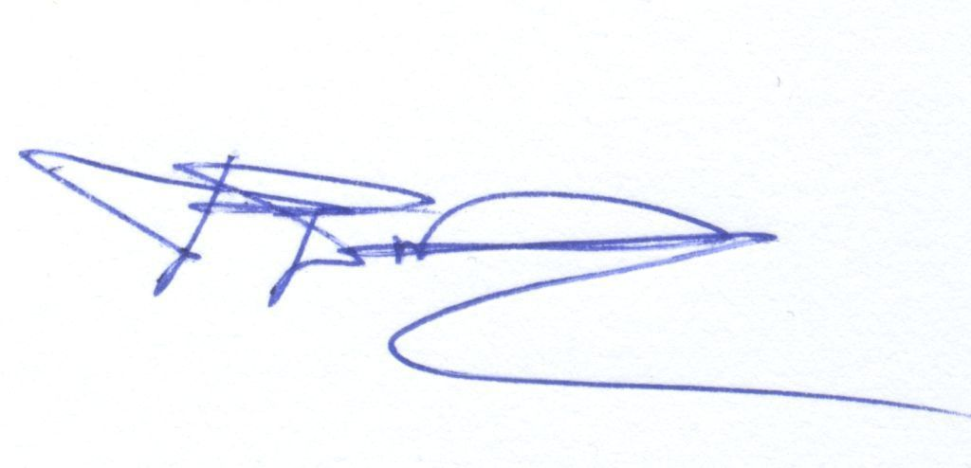  Daniel Dumitran, Chief Editor

Please return to the following address:

"1 Decembrie 1918" University of Alba Iulia
Alba Iulia, 5 Gabriel Bethlen St., 510009, Romania
Tel.: +40 (0)258 811412; Fax: +40 (0)258 806260

or e-mail to: aua_historia@uab.ro.

